**LabVIEW 101 – Weeks 10, 11**

Before class:

1. Download updates from <https://github.com/rizett/LabVIEW-101>
2. Download and Install RealTerm

* [https://sourceforge.net/projects/realterm/files/latest/](https://sourceforge.net/projects/realterm/files/latest/download)
* NOTE: going to this link will start download automatically.

Required equipment:

Computer with LV and RealTerm installed

1x Optode

1x GTD

1x Winkler Pump

1x Winkler Meter

3x USB-to-Serial

Topics:

Sending and reading data via serial

* Last week (week 10):

Interfacing with serial devices in Real Term

Setting up serial communication in LV

Using Valco Valves to control inflow/outflow sample

* This week (week 11):

2-way communication between serial device and computer – Optode, GTD, Winkler Pump & Meter

Think about your projects!

**Note on CR/LF:**

CR = Carriage Return ( \r , 0x0D in hexadecimal, 13 in decimal) 🡪 moves the cursor to the beginning of the line without advancing to the next line.

LF = Line Feed ( \n , 0x0A in hexadecimal, 10 in decimal) 🡪 moves the cursor down to the next line without returning to the beginning of the line

**Note of VISA resources:**

VISA resource is passed from one VI to the next

**Week 10: Sending serial commands/information**

1. Valco valves
   1. RealTerm Commands (goX; cp)
   2. Setting RealTerm default settings (-port=A,-baud=B)
   3. LabVIEW
      1. Comp port: (FP): Modern > IO > VISA Resource Name
      2. NI-VISA: (BD) Instrument IO > VISA > Serial
         1. **Configure Port**: set up port settings
         2. **Flush buffer**: clear read/write buffer
         3. **Write**: Write to serial
         4. **Read**: Read from serial

**Week 11: Sending and receiving serial commands / information using different instruments in the lab**

1. Optode:



* 1. Settings: port, 9600 (baud), 8, none, 1
  2. Serial commands
     1. start
     2. stop
     3. get interval
     4. set interval(N)
     5. get all
     6. do sample
     7. **terminated by Carriage Return and Line Feed**
  3. Output data:



1. GTD:
   1. Settings: port, 19200 (baud), 8, none, 1
   2. Commands (entered in RT window):
      1. Escape
      2. 1
      3. 2
   3. Output data:

P 2016,04,22,13,56,53,1007.774,21.263,12.0,2349,1821,0,0

**\*\*Each data line is terminated with a carriage return linefeed, CRLF.**

1. Winkler meter
2. In LabVIEW:
   1. Comp port: (FP): Modern > IO > VISA Resource Name
   2. NI-VISA: (BD) Instrument IO > VISA > Serial
      1. **Configure Port**: set up port settings
      2. **Flush buffer**: clear read/write buffer
      3. **Write**: Write to serial
      4. **Read**: Read from serial
   3. Basic string commands:

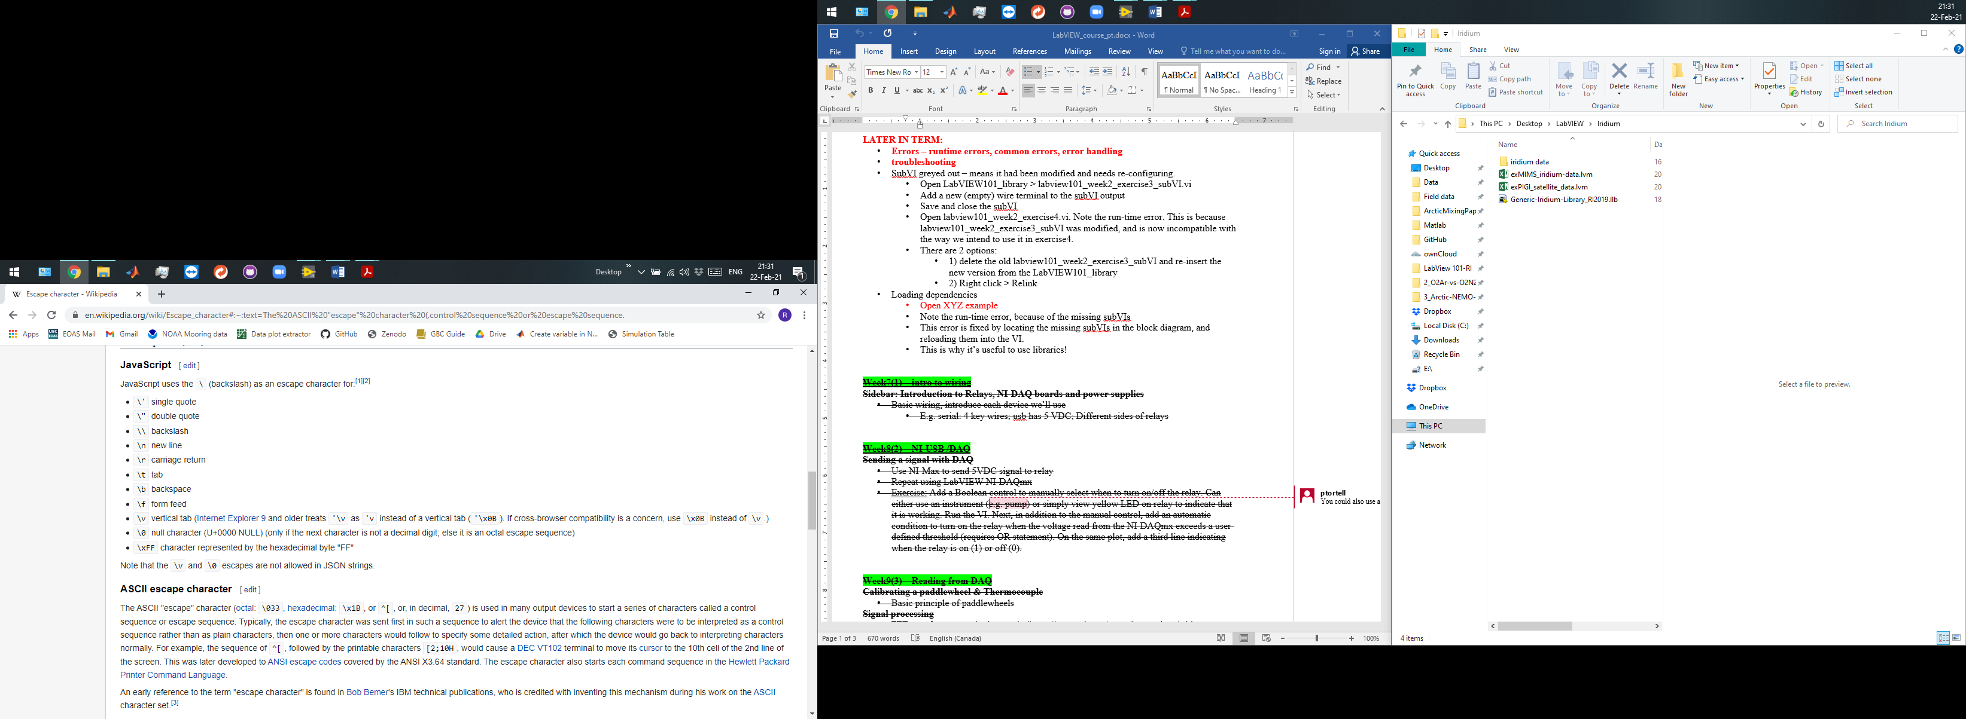

* 1. Parsing strings: pattern recognition
     1. **Scan from string:** String > Scan from string
        1. Inputs:
           1. Input string
           2. Pattern

Match the type of data you want to read (see below – and detailed help for “Format specifier syntax”)

* + - * 1. Starting position (defaults = 0)
        2. Default values
      1. Outputs:
         1. components of string (converted)
         2. Remaining string
    1. Or Match pattern / Match regular expression (both on string palette) to pick out a subset of a string that has a regular/recognizable pattern

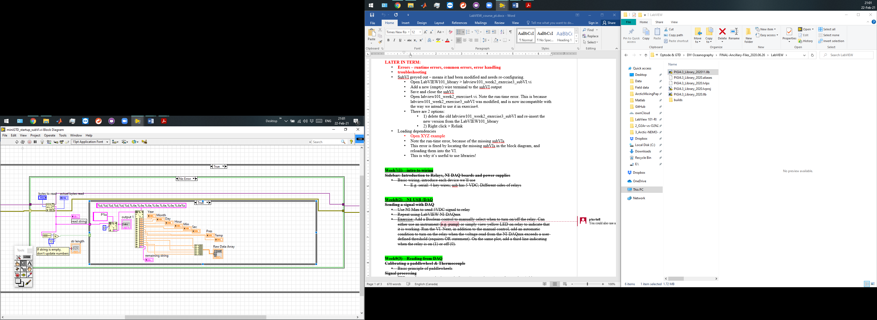

Exercise:

1. Create a desktop shortcut to a Real Term terminal for your instrument (Optode, GTD, volt meter, or an instrument of your choice)
2. In Real term, get comfortable with the commands and how to interface with the instrument. Note how data are printed out
3. Create a new VI to:
   1. Start / wake your instrument
   2. Read a line of data and parse the signal on command (e.g. obtain a sample when a button is pressed)
   3. Read several lines of data and plot one of the output variables versus time.